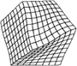
Resonant Ultrasound Spectrometer
RUS008
Alamo Creek Engineering
www.rusalamocreek.com
+1 (505) 670-9858

Alamo Creek Engineering RUSpy application manual: 1 March 2022
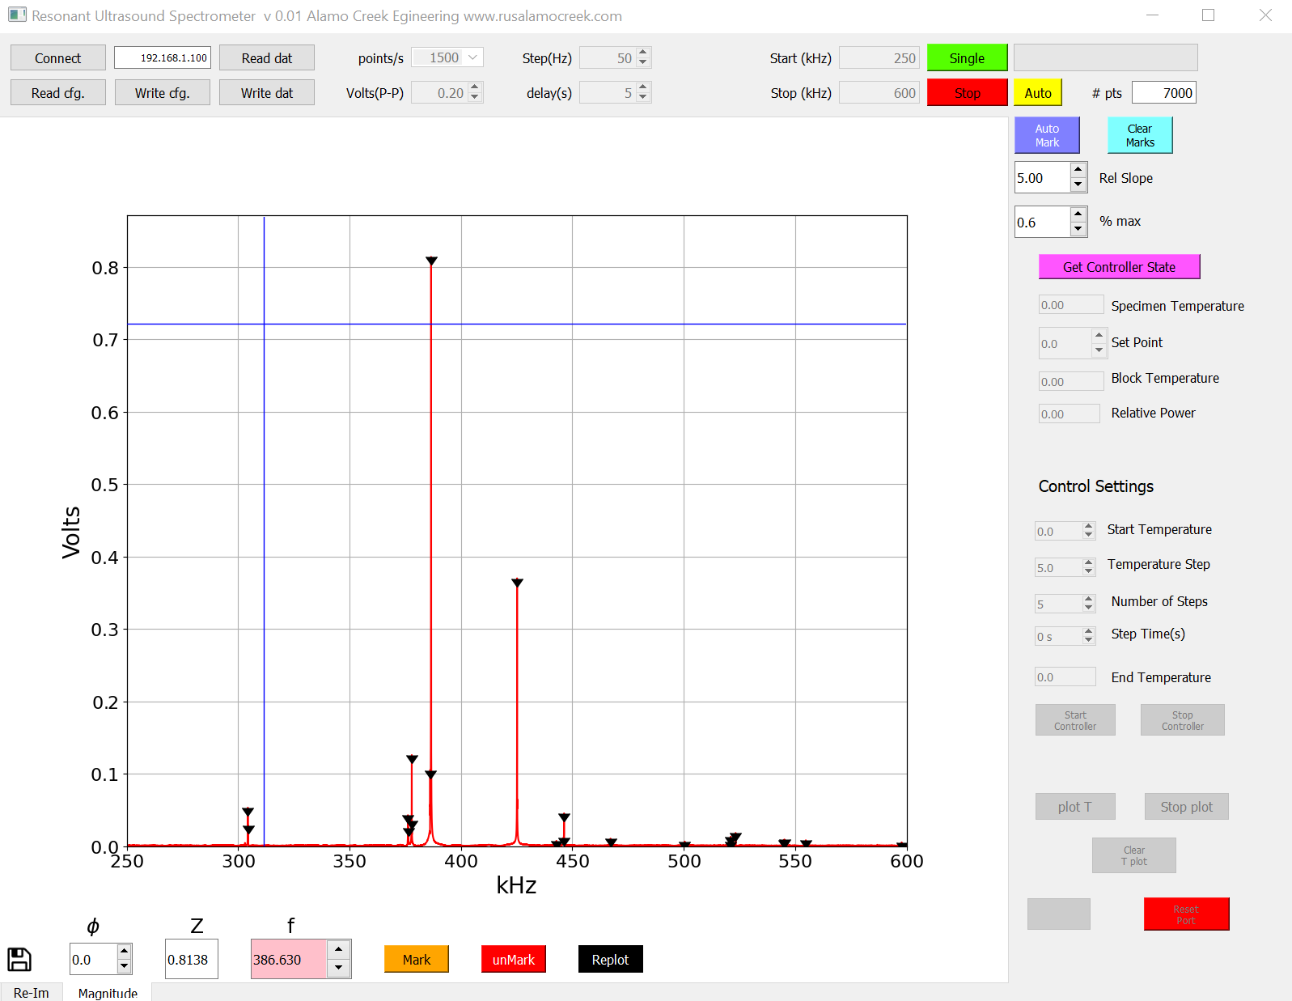

Installation:
- Copy entire contents of USB drive to a folder on your desktop. The subfolder /Data must be present.
- Copy entire contents of subfolder RUS Spectrometer Firmware to root of a formatted blank micro sd card. Insert into ACE RUS008 spectrometer.
- If necessary, use Arduino IDE to update temperature controller firmware. The updated firmware will run under either the LANL Labview control program or the ACE Python control program.
- The RUSpy.exe file is the windows executable of the Python 3.8 data acquisition program. (Source code is available at https://github.com/rus-ace/RUSpy). It will auto detect both the High Temperature option and the Thermoelectric stage.

Description of control functions:
Note-- subfolder of folder with RUSpy.exe “Data” must be created by user.
Note--the little floppy disk icon takes a high resolution screen shot of the graph.
- Disconnect--Connect: Connects PC to RUS 008 at address 192.168.1.100. This is not editable.
- Read cfg.--Write cfg: Stores current sweep settings in file xx.ini. This is an editable text file.
- Read dat—Write dat: Stores raw real and imaginary sweep data in file located in subdirectory /Data. This can be read back in and processed just as if a scan were taken. The file name is like 296.0_K_21022022082920_D.dat where the temperature of controller set point is first, and the day, month, year, and time in hh.mm.ss. format. If no controller is present, the temperature is replaced by 0.0. The Specimen Temperature is replaced by the temperature recorded during the sweep. The first line of the file is specimen temperature if a controller is connected, otherwise it is 0.0. The second line is drive voltage. The remainder contains the raw data:
0.00
1.00 V
frequency real imag
250.00 0.0002557 0.0001221
250.01 0.0001736 0.0003753
250.02 0.0002193 0.0004464
250.03 0.0002906 0.0003615
…
- points/s: this is a spin box with useful (non editable) values of the rate at which spectrum data is acquired. The lower the rate, the more noise reduction.
- Volts(P-P): The actual spectrometer transducer drive voltage. It is editable and goes from 0 to 25 V P-P.
- Step(Hz): The step between successive data points.
- delay(s): The delay between sweeps when Auto sweep is selected. Sweep data is written after each sweep
- Start(kHz)--Stop(kHz): The start end end frequencies for a sweep. This is editable.
- Single--Stop--Auto: Initiates a single sweep, stops a single or auto sweep, or initiates auto sweep at intervals of delay(s). The progress bar indicates the sweep state during a sweep.
- # pts: The number of data points in the sweep.
- Auto Mark--Clear Marks--Rel Slope--%max: Peaks are detected and show as black triangles. Any data below % mark is ignored—this is a threshold. Rel Slope is a parameter that basically determines how sharp a peak is. It uses a calculation of the RMS noise taken from the first 16 points of the sweep. Therefore, those 16 points must not contain a resonance. The higher the number, the steeper the slope must be for inclusion in the list. The frequencies found are written in ascending order to e.g. 296.0_K_21022022101400_F.dat in /Data. (The first part of the file name is the integer of rounded off specimen temperate) in the format
“freq amplitude 1.0”
so that the results can be cut and pasted into the analysis code input file. The file is updated at any change in found peaks. Clear Marks removes all peaks both from plot and file.
- Re-Im--Magnitude tabs: Plots Real/Imaginary data or magnitude data.
- Blue crosshair cursor--Mark--unMark--Replot--black vertical cursor—blue crosshair appears when mouse is inside plot area. This cursor is used to select a region for processing. Only the vertical line determines the box size, and the selected region is auto-scaled to fit. Inside that region is a second black vertical cursor whose height is the height of the datum at that point. The datum height is displayed in the editable spinbox “f” The black cursor always first appears at the highest data point in the window. Clicking “Mark” will add the point at the cursor to the *.F.dat file, which sorts that frequency to maintain an ordered list. The spinbox “f” is the only way to move the black cursor. If moved to another peak in the window, “Mark” will add that peak to *.F.dat. Clicking unMark will remove from plot and file any marked peaks in the window. This is useful to remove spurious peaks as in the region around 350kHz. Replot plots the entire sweep with marked points visible. The marked points show in both Re-Im or Magnitude plots.
- ɸ: In the Re-Im plot, you can roll the phase around with the spinbox.

Saved data:
- Read Dat--Write Dat: The raw data file can be read in from the \Data directory just as if a scan were taken, and analyzed with the various peak mark and detect functions, writing a *F.dat file with the result.
- The drive voltage for the scan appears in Volts(P-P) window, and the temperature is displayed in the Specimen Temperature window.

Temperature control:
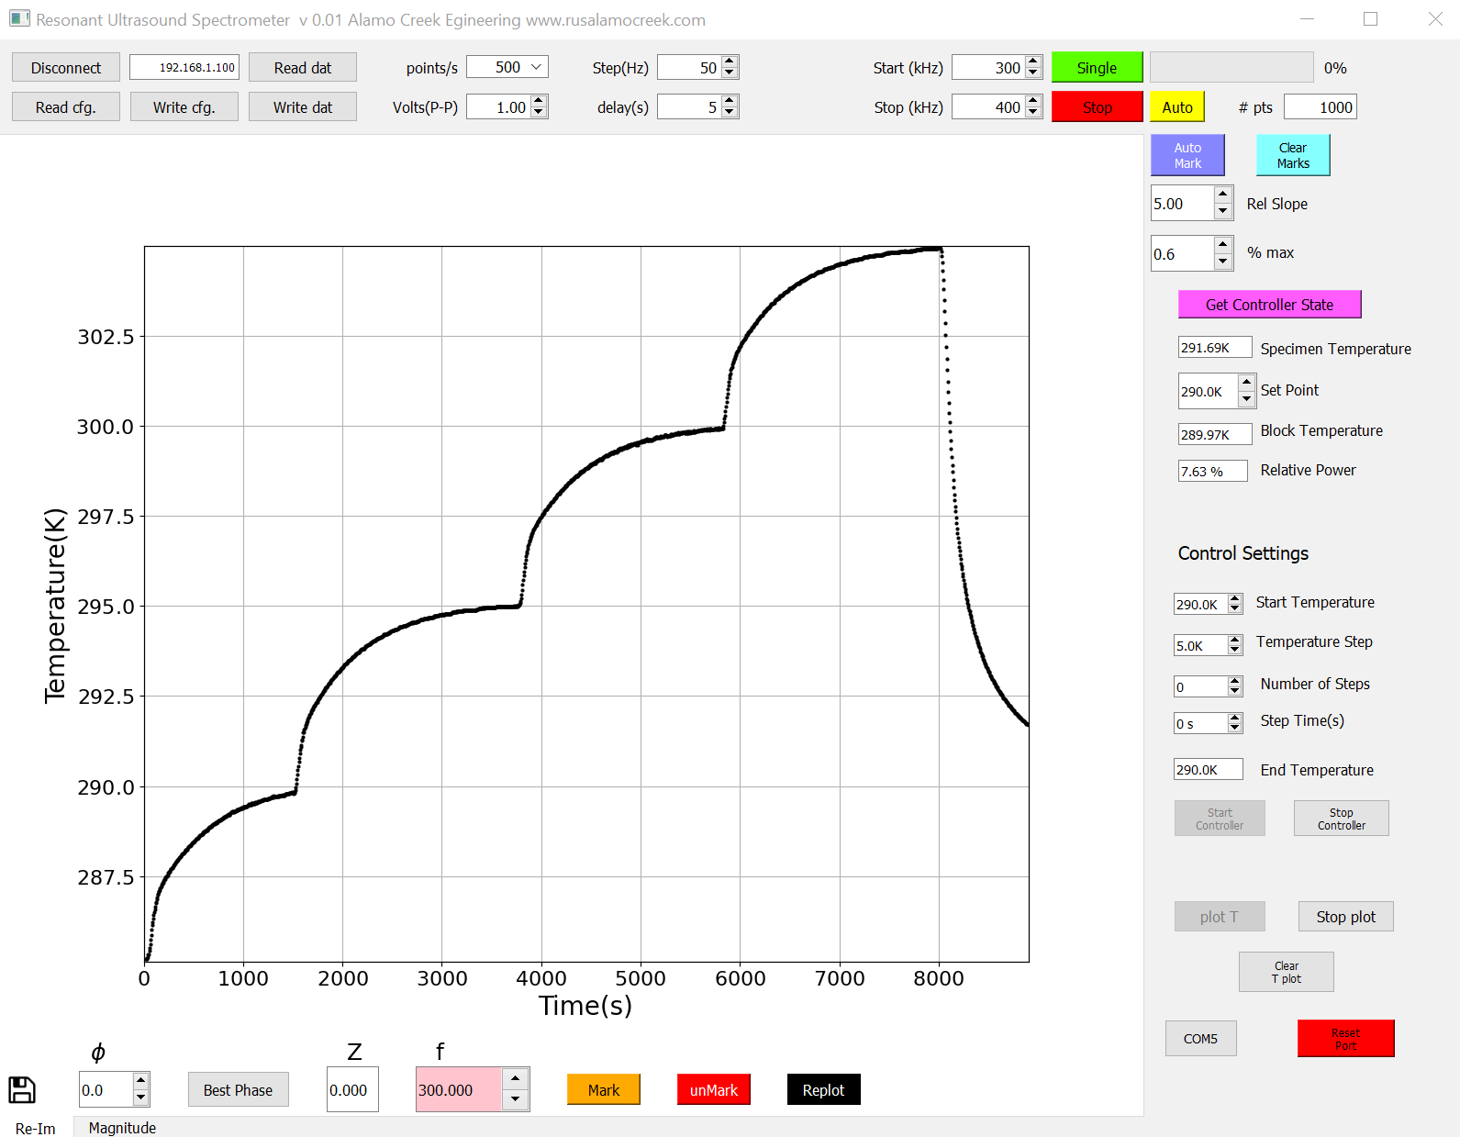
- There are two modes of operation. Python and Labview. Peak detection does not work in either mode during control and the spectrum does not plot.
- If an ACE temperature controller with latest firmware is present, it will be detected, the controls for it will be made active, and the com port shown.
- If necessary, the Reset Port button will reset the temperature controller.
- Entering a Set Point immediately changes the control temperature to that value when in non-temperature-sweep mode.
- Clicking Get Controller State reads all available controller values. Controller values are not automatically updated unless plot T is active.

To access closed-loop mode (Python mode), set Step Time(s) = 0.
- Set the Start Temperature, Temperature Step, Number of Steps. The End Temperature is computed from these.
- Click plot T and click Start Controller. The Get Controller State is updated continuously.
- The system will go to each temperature (see figure above) test for equilibration, take a scan,
- Each scan will write a data file like 296.0_K_21022022082920_D.dat where the temperature of controller set point is first, and the day, month, year, and time in hh.mm.ss. The first line of the file is temperature at end of sweep, the second line, drive voltage, and the rest, the raw sweep data in “Freq, Real, Imag” format. Temperature units are auto detected and are either C for the high temperature option, or K for the thermoelectric stage.
- At the end, the temperature returns to the start temperature.
- Click Stop Plot and Stop Controller to return to normal operation.

To enter Labview mode, an open-loop mode where equilibrium is not detected, set Step Time(s) > 0 seconds and Temperature Steps so that the temperature changes slowly enough that the sample temperature is close to the Specimen Temperature. The idea is to make small temperature steps with adequate time between them for equilibration. This mode is not recommended.
- Set delay(s) for the desired delay between scans. Note that it is important that the total time for a scan cycle = delay(s)+the time for a scan be much shorter than Step Time(s). Each scan will write a data file like 296.12_C_21022022082920_D.dat with the file name the temperature at end of scan as the first characters, the first line of the file is specimen temperature at end of scan, the second line, drive voltage, and the rest, the raw sweep data. Set Start Temperature. Set Number of Steps. The End Temperature is computed and displayed.
- Click plot T to start a graph of temperature vs time. All but the set point of Get Controller State will update continuously. Clear T Plot resets the temperature time axis to zero.
- Click Start Controller to send the temperature program to the temperature controller. At this point, the temperature controller operates independently of RUSpy.exe.
- Click Auto to begin data acquisition at the intervals set by delay(s).
- The progress is seen in the progress bar. Note that the Block Temperature is only valid for the thermoelectric stage, as that is the temperature actually controlled.
- The Specimen Temperature will be displayed as things progress, but not the Set Point. The Relative Power is also displayed,
- At the end of the temperature program, the temperature stays at the End Temperature.
- Click Stop Plot and Stop Controller to return to normal operation.

Strategy for finding peaks:
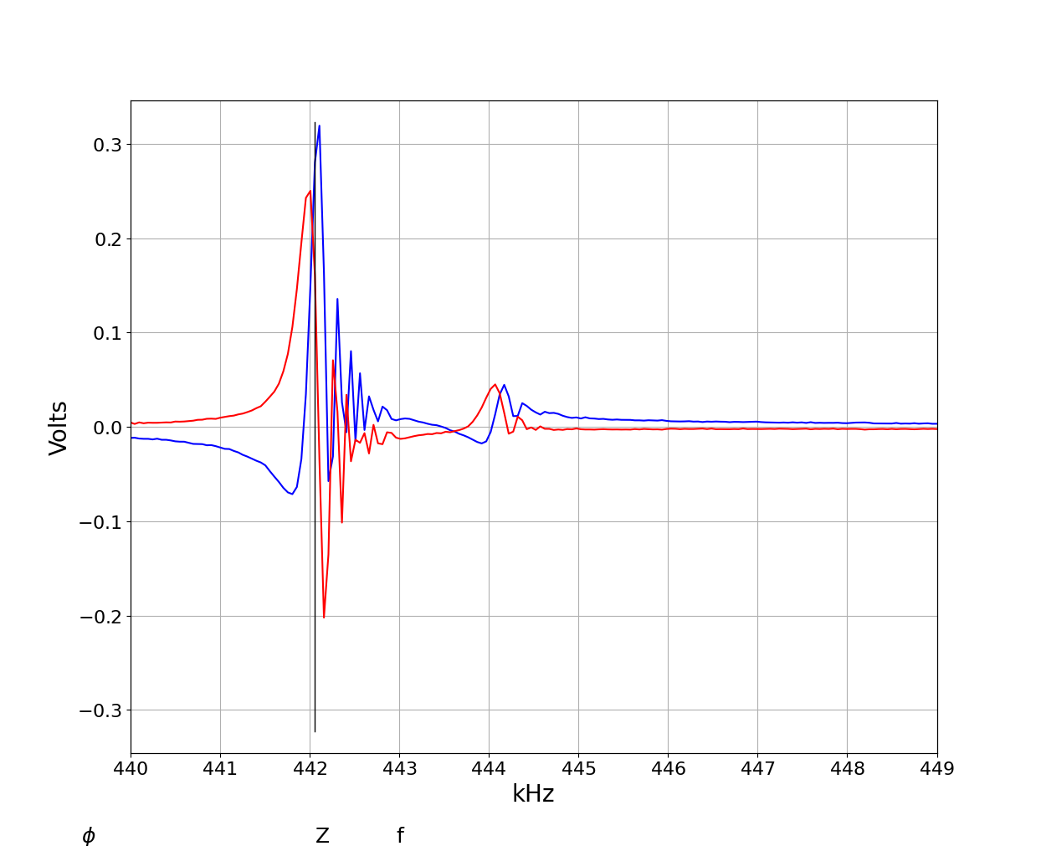
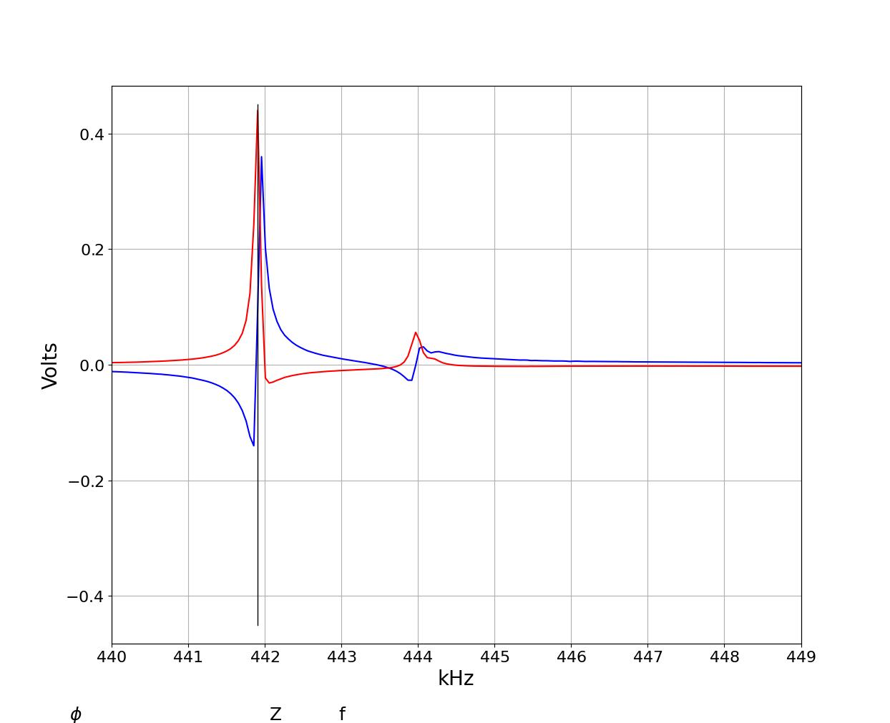
The figures below were both taken at 50 Hz steps, but the one on the left at 1500 pt/s, the one on the right at 50 pt/s. Both are screen shots using the floppy icon.

The difference is actually physics. With a high-Q resonator, running through the resonance faster than it can ring down produces a beat frequency between the resonator fundamental frequency and the drive frequency, causing the sawtooth for the scan on the left. It is, nevertheless, very useful in determining if the sample is producing good signals, to run at 1500 pts/s until a good spectrum is obtained. Then, for the actual measurement, use one of the lower rates. The sharper the resonance, the lower the rate required to prevent ringing. Note that the peak detector on this scan only detects the correct peaks at either rate, but that is not to be counted on. The sawtooth may generate spurious detected peaks.

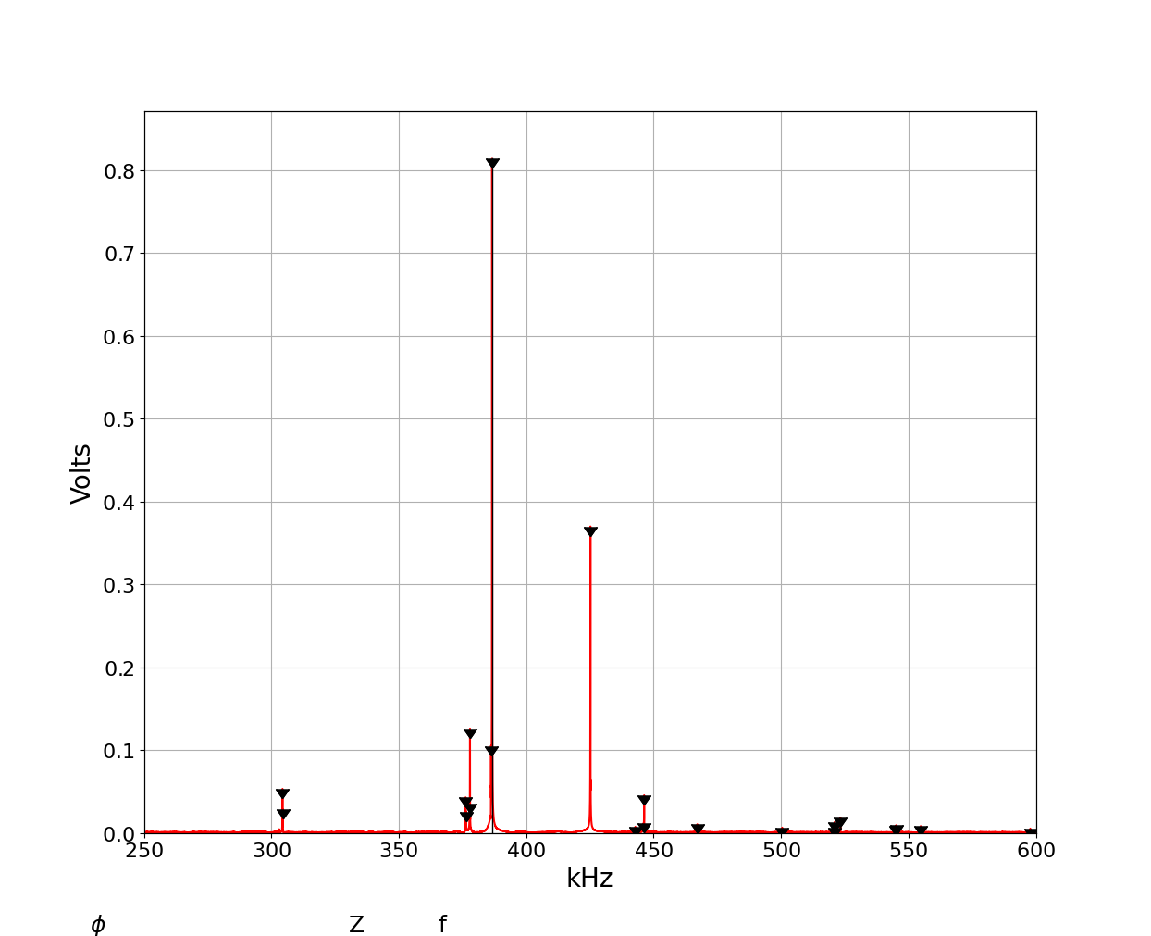
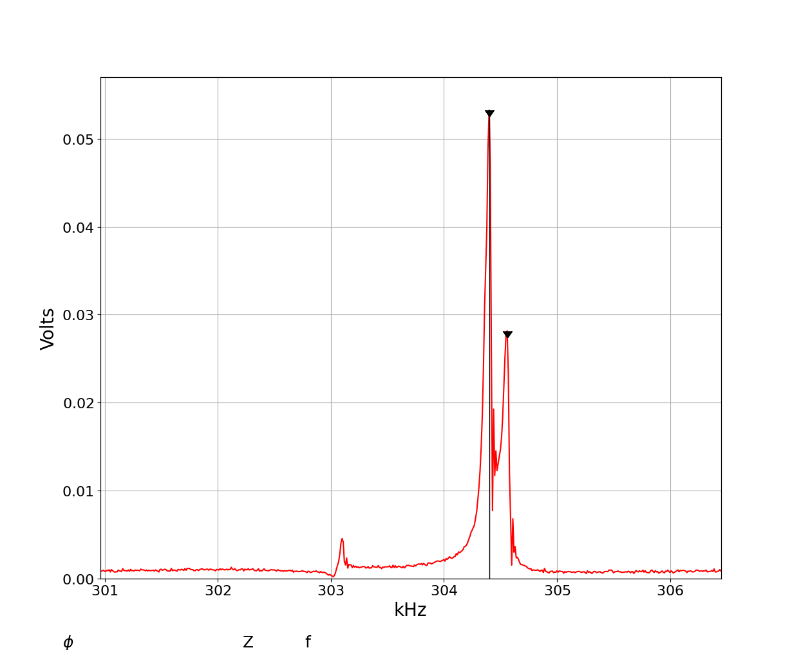
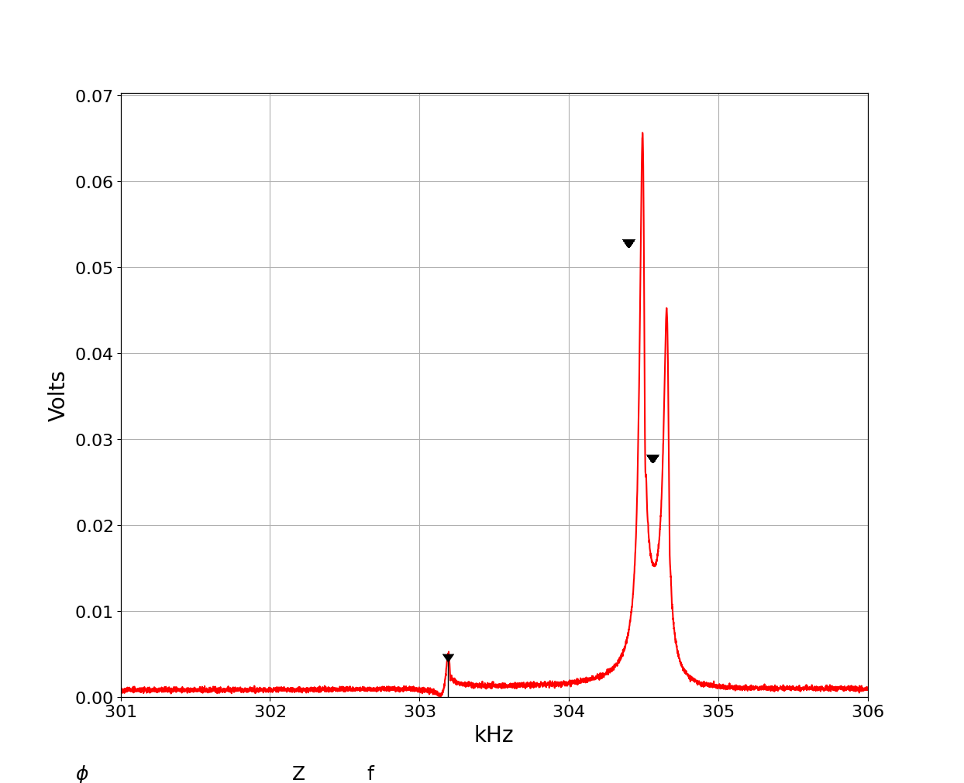
The code is hard-limited to 32766 data points. For a broad scan on high-Q material, it may not be possible to eliminate ringing with even the slowest acquisition rate. Using the blue crosshairs, ringing is visible. Rescanning at very small steps just the region in question to be sure if a peak is real or ringing, produces a plot where one can add a frequency using the black cursor to the list without losing the already-detected peaks. Note that the previously detected peaks are now slightly shifted. This is a common issue associated with tiny variations between scans from vibration, temperature etc.

The peak added just above 303 kHz is most easily added by using the blue crosshairs to isolate it, because moving the black cursor with arrows will put it in a region of low signal, making it nearly invisible. Note that auto detecting peaks will result in duplicates now, because of the slight shift.
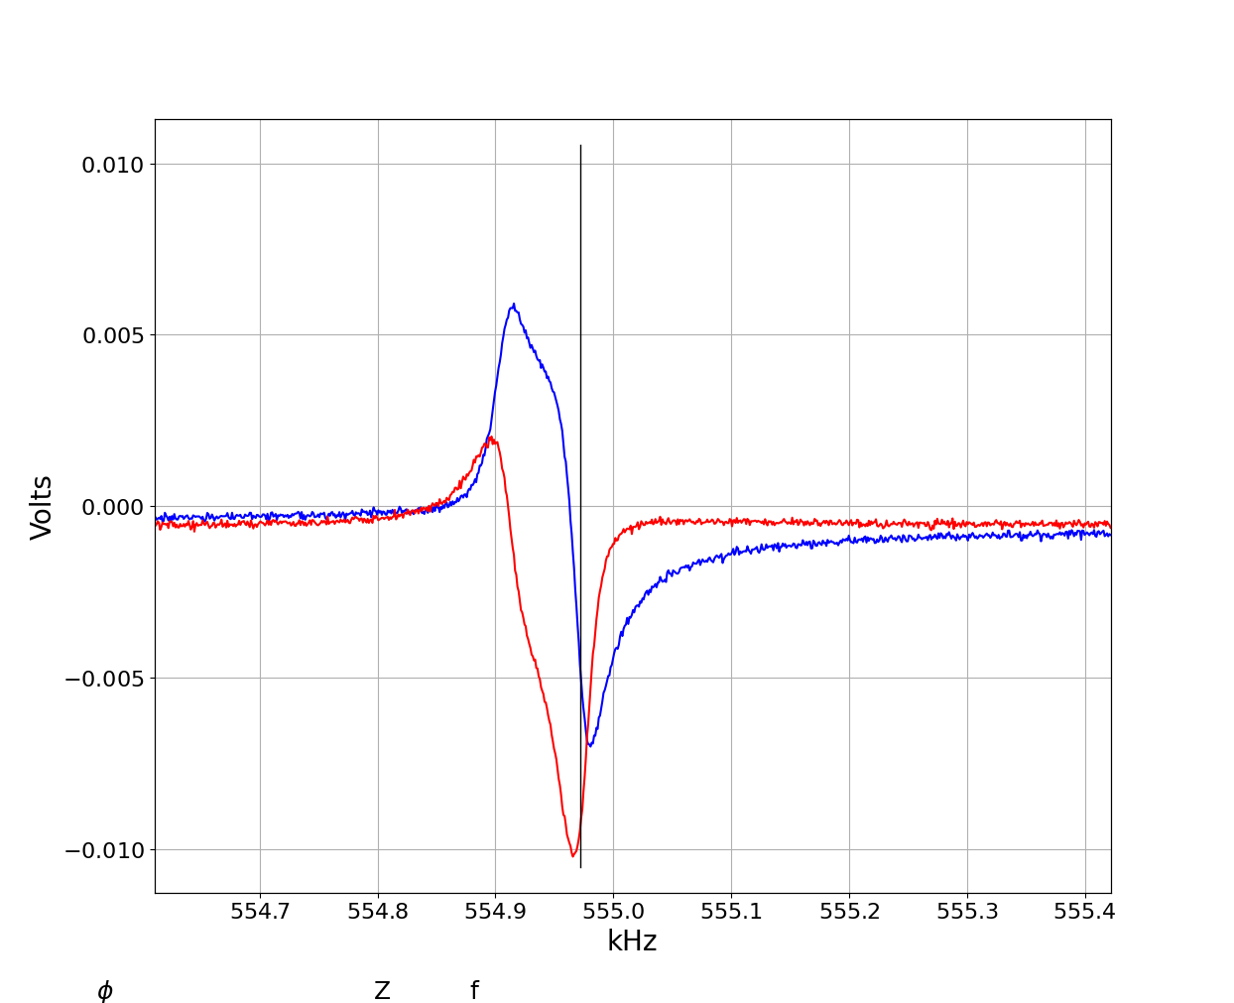
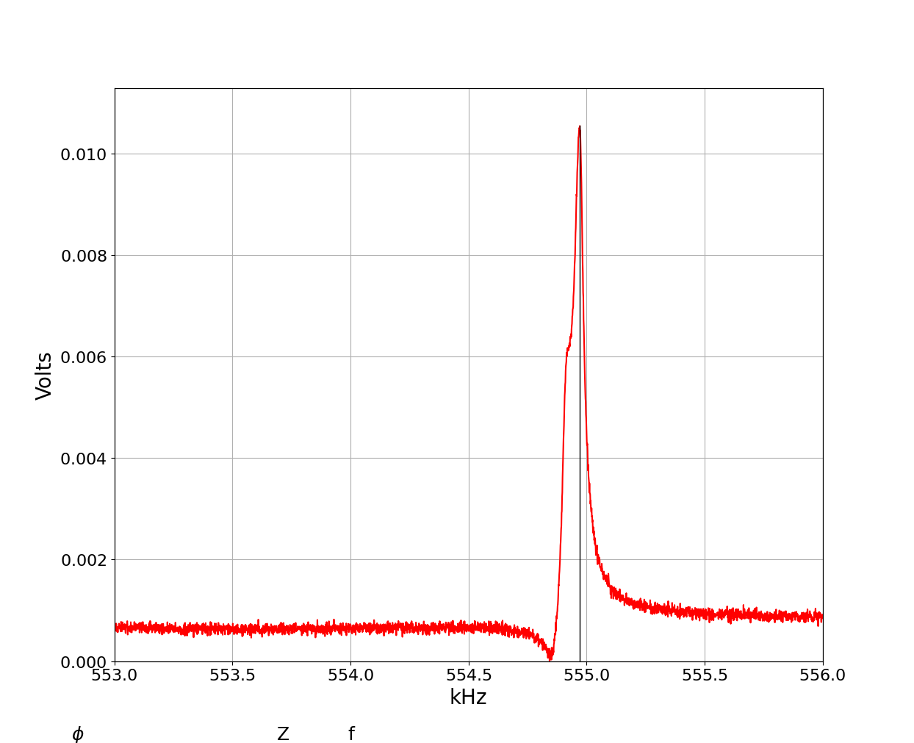
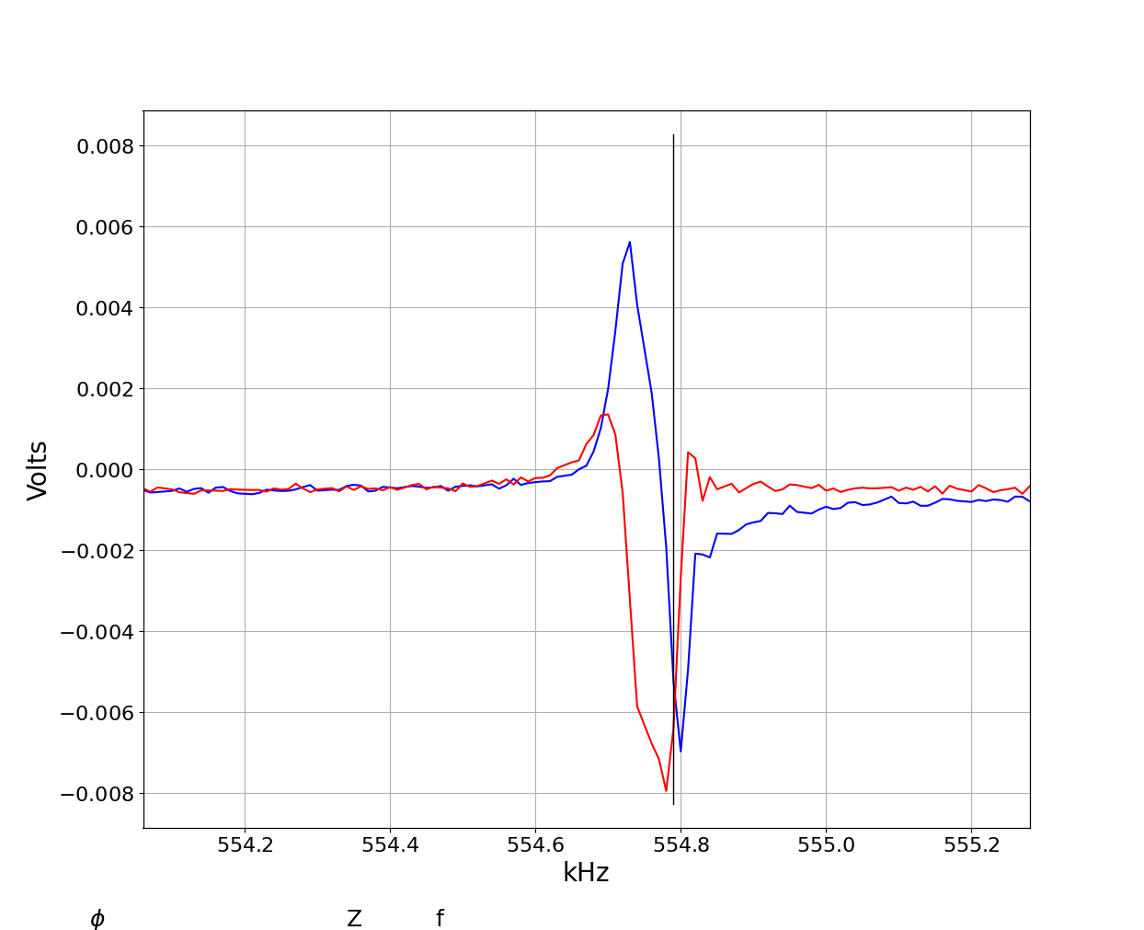
It is also useful to look at the re-im plot at small steps if a peak is questionable. The distorted shape is a giveaway.

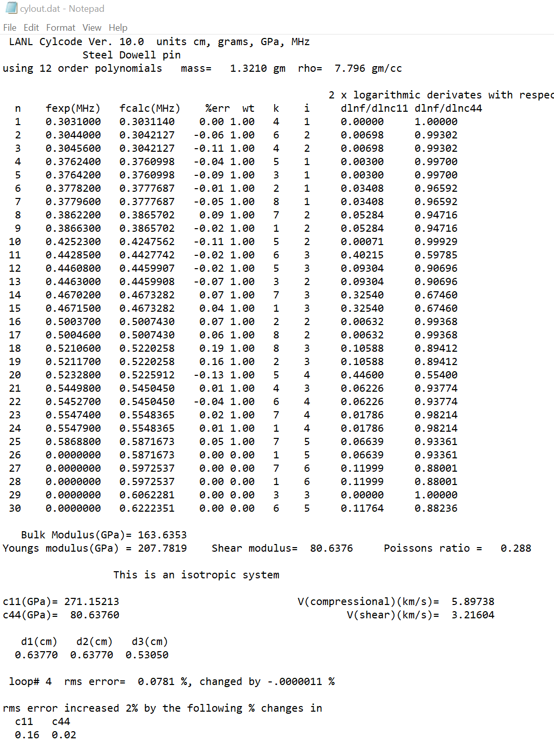
Note that every single peak predicted by the code is found in the single scan without repositioning the sample. This may not always be the case, but one does not need to find every peak for a good fit. However, it is essential to find the lowest mode. That mode was not detected with the peak finder but had to be added manually using the black cursor. Here is the result for the sample data supplied with these instructions.

Note that the doublet at 587 kHz is not included as a doublet. Try yourself to see if it is there. You will find that it is.

